Explanation of the Architecture for Passenger Safety in a Semi-Autonomous Vehicle
This architecture diagram explains how the in-car safety project works. At the center of the project lies the Jetson developer kit; we can also say it is the heart of the project where all the processing is done. We are using a combination of sensors in this project, which are Zed 2 camera, ECG sensor, and Wi-Fi sensors for communication purposes. Along with an “ADS1115” analog-to-digital converter.
When we look at the architecture diagram for passenger safety in a semi-autonomous vehicle, we can see that all the inputs are coming to the Jetson board at the end. Firstly, the sensors like Zed 2 cam and ECG sensor will connect the data. As the Zed 2 camera is giving the data in digital format, the Zed 2 camera can directly read and process it, but the ECG sensor can only give data in analog, so we will be using an analog-to-digital converter, which will convert the analog data into digital data, which will then be taken as input by the Jetson developer kit.
All this data is collected and sent to the Jetson developer kit in digital format. The Jetson comes with some built-in tools which can do deep learning and many more things. Here in this case, we will be taking the input from the camera. We will be processing the data using YOLO. What it does is that it will take the data and process it by using RESNET, POSENET, GAZENET.
YOLOv8 : YOLO is a real-time object detection model that detects objects in the image or video in a single forward pass of the neural network. YOLO has single-stage detection, improved accuracy, and speed. It supports multiple tasks, and out of all, it is easy to use.
According to the diagram, we will be taking the input image. The backbone of the YOLO algorithm is that it will take multiple images as input and process them. The next step is to process the neck portion where we will be using FNP and PAN. FNP will detect and process the data from top to bottom, and PAN will process the data from bottom to top. This same process is repeated while detecting the head position of the person; then, this data is processed by RezNet.
REZNET: ResNet is a neural network architecture used to detect the pose and gaze of the passengers in the car. It mainly focuses on image classification and feature extraction. We will be taking an image as input and giving the output as class label or features.
POSENET: PoseNet is a sub-portion of ResNet where it is used to detect the posture of the human being. A photo of the person is taken by PoseNet as input, and the output is given in X,Y key points of the body joints.
GAZENET: GazeNet is also a sub-portion of ResNet used for gaze detection using eyeball movements. For this, we will take an image of the face or eye as input. And it’ll give eye gaze direction coordinates as output, which we can use to detect the eye gaze.
The final step in this process involves completing the data processing on the Jetson board. If the system detects that the passenger is in danger, a code is activated, triggering a notification to emergency services and the passenger’s relatives via the V2X communication protocol.
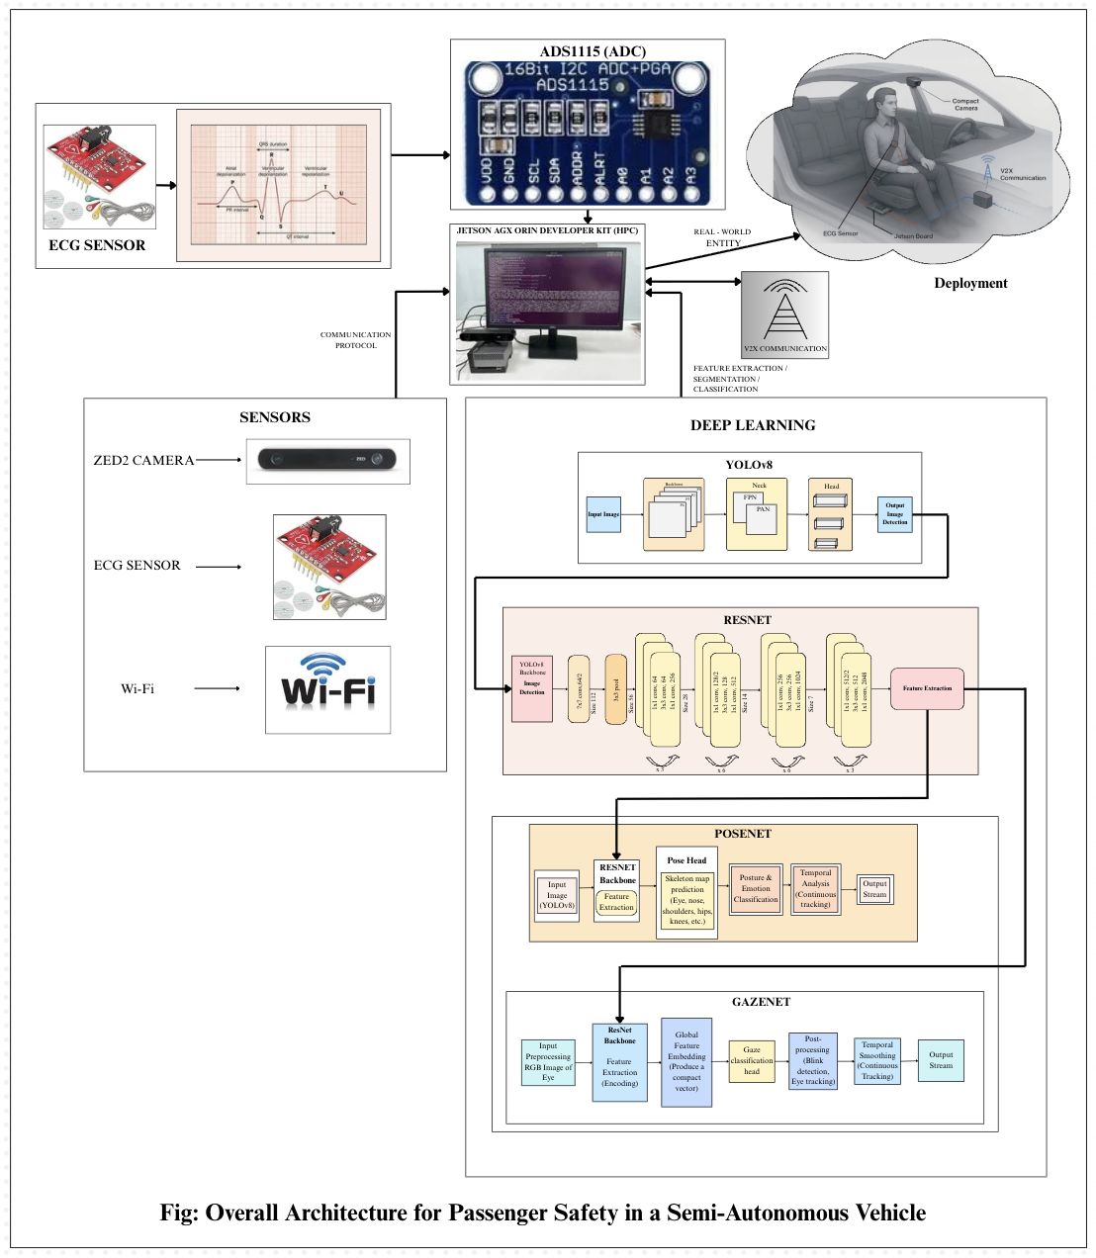
This architecture diagram illustrates how the project in car safety will be implemented and executed.

